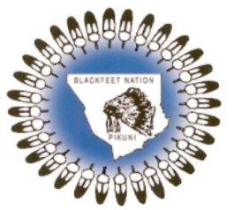 | Blackfeet Fish & Wildlife Department | 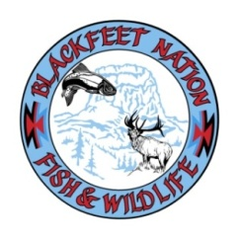
 | P.O. Box 850
 | Browning, MT 59417
 | Phone: (406)338-7207
Fax: (406) 338-4751
blkft.fishandwildlife@gmail.com

Yellowstone Bison Hunting regulations acknowledgement

I, ______________________, acknowledge that I have carefully read the Blackfeet Nation – Yellowstone Bison Hunting regulations and that I hereby agree to comply with these tribal regulations while engaged in off-reservation hunting of bison, elk, deer, and antelope upon open and unclaimed lands within the aboriginal territory of the Blackfeet people.

I agree to comply with CWD sampling and carcass disposal regulations and to obey all Forest Service, National Park Service, and Bureau of Land Management regulations that pertain to the tribal bison hunt in the West Yellowstone and Gardiner areas of Montana.

I hereby agree to report any harvest of bison, elk, deer, or antelope to the Blackfeet Fish and Wildlife Department within 7 of the kill or if unsuccessful no later than 7 days after the season close.

Printed Name:__________________________________________

Signature______________________________________________

Date:__________________ Phone #_____________________

